Christopher Passerini
September 20, 2026
CS-360-11096
Professor Alex Benavente

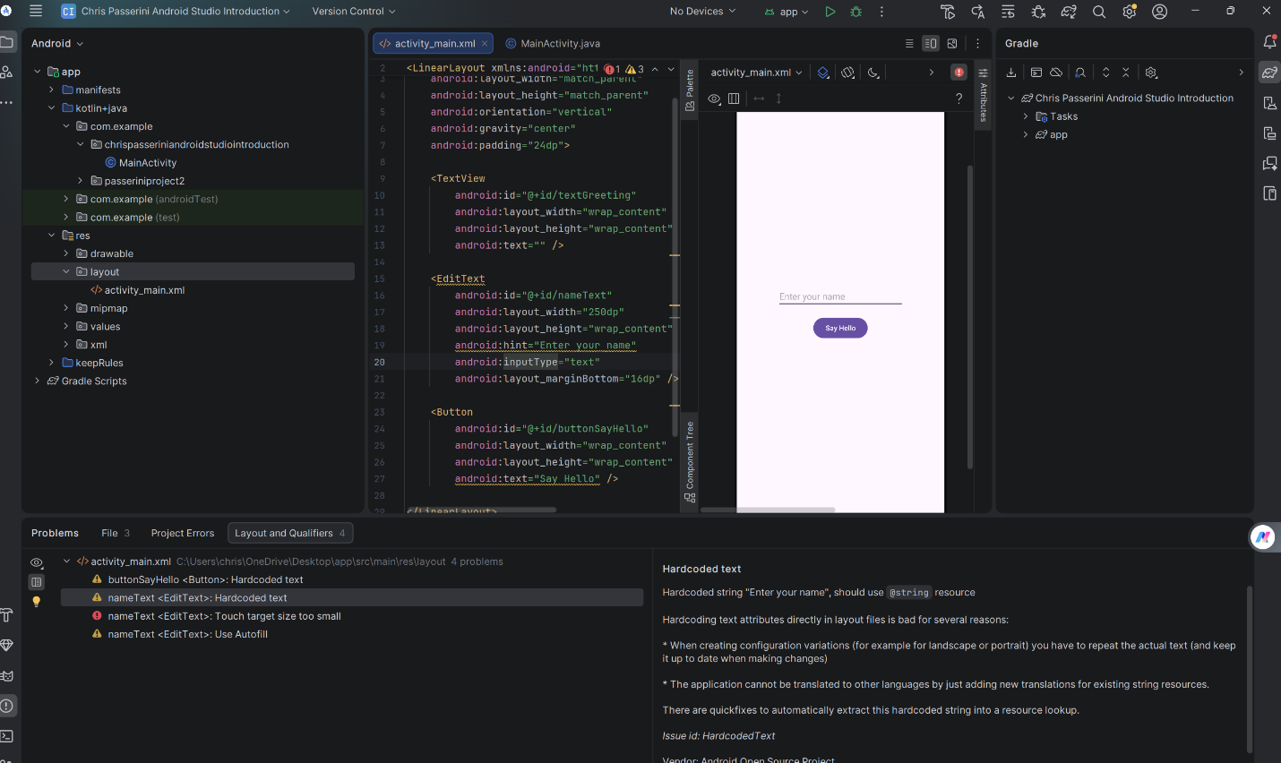
During the initial setup of my Android Studio project, my primary challenge was navigating the lengthy configuration process required during the application’s first launch. Because the software needs to download the Android SDK, Gradle build toolchains, and numerous system dependencies, I had to wait roughly thirty minutes before the environment was responsive enough to begin actual development. This initial background downloading period felt exceptionally slow and added unexpected friction to starting the assignment.
Once the project synchronized and synced its local files, I hit another hurdle: adjusting to the user interface. Because Android Studio is an entirely new development environment for me, the vast layout editor and multi-pane workspace felt quite overwhelming at first glance. It took some deliberate trial and error to locate the component palette and map out where to modify object properties. Furthermore, configuring functional vertical and horizontal constraints in the layout editor proved difficult at first. I struggled to keep my button, text view, and plain-text input fields anchored in their designated screen positions rather than snapping unexpectedly back to the upper-left margin during execution. Overcoming these initial technical and spatial learning curves required patience, but it provided valuable foundational insight into the platform's layout lifecycle.

